PANIMALAR INSTITUTE OF TECHNOLOGY
DEPARTMENT OF IT
CCS354 NETWORK SECURITY
UNIT III ACCESS CONTROL AND SECURITY
Network Access Control: Network Access Control, Extensible Authentication Protocol, IEEE 802.1X Port-Based Network Access Control - IP Security - Internet Key Exchange (IKE). Transport-Level Security: Web Security Considerations, Secure Sockets Layer, Transport Layer Security, HTTPS standard, Secure Shell (SSH) application.

NETWORK ACCESS CONTROL
Network access control (NAC) is an umbrella term for managing access to a network. NAC authenticates users logging into the network and determines what data they can access and actions they can perform.

Elements of a Network Access Control System
NAC systems deal with three categories of components:
- Access requestor (AR):
- The AR is the node that is attempting to access the network and may be any device that is managed by the NAC system, including workstations, servers, printers, cameras, and other IP-enabled devices.
- ARs are also referred to as supplicants, or simply, clients.
- Policy server:
- The policy server determines what access should be granted.
- The policy server often relies on backend systems, including antivirus, patch management, or a user directory, to help determine the host’s condition.
- Network access server (NAS):
- The NAS functions as an access control point for users in remote locations connecting to an enterprise’s internal network.
- Also called a media gateway, a remote access server (RAS).

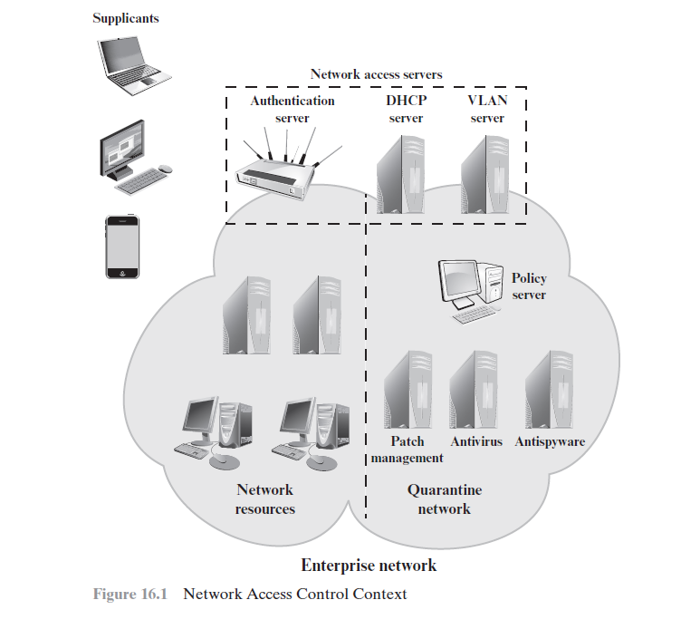
- The above Figure is a generic network access diagram. A variety of different ARs seek access to an enterprise network by applying to some type of NAS.
- The first step is generally to authenticate the AR. Authentication typically involves some sort of secure protocol and the use of cryptographic keys.
- Authentication may be performed by the NAS, or the NAS may mediate the authentication process.
- Once an AR has been authenticated and cleared for a certain level of access to the enterprise network, the NAS can enable the AR to interact with resources in the enterprise network.

Network Access Enforcement Methods
Enforcement methods are the actions that are applied to ARs to regulate access to the enterprise network.
The following are common NAC enforcement methods.
- IEEE 802.1X:
- This is a link layer protocol that enforces authorization before a port is assigned an IP address.
- IEEE 802.1X makes use of the Extensible Authentication Protocol for the authentication process.
- Virtual local area networks (VLANs):
- In this approach, the enterprise network, consisting of an interconnected set of LANs, is segmented logically into a number of virtual LANs.
- The NAC system decides to which of the network’s VLANs it will direct an AR, based on whether the device needs security remediation, Internet access only, or some level of network access to enterprise resources.
- Firewall:
- A firewall provides a form of NAC by allowing or denying network traffic between an enterprise host and an external user.
- DHCP management:
- The Dynamic Host Configuration Protocol (DHCP) is an Internet protocol that enables dynamic allocation of IP addresses to hosts.

EXTENSIBLE AUTHENTICATION PROTOCOL
The Extensible Authentication Protocol (EAP) acts as a framework for network access and authentication protocols.

Authentication Methods
EAP supports multiple authentication methods.
EAP-TLS (EAP Transport Layer Security):
- EAP-TLS defines how the TLS protocol can be encapsulated in EAP messages.
- EAP-TLS uses the handshake protocol in TLS.
- Client and server authenticate each other using digital certificates.
- Client generates a pre-master secret key by encrypting a random number with the server’s public key and sends it to the server.
- Both client and server use the pre-master to generate the same secret key.
EAP-TTLS (EAP Tunneled TLS):
- EAP-TTLS is like EAP-TLS, except only the server has a certificate to authenticate itself to the client first.
EAP-GPSK (EAP Generalized Pre-Shared Key):
- EAP-GPSK, is an EAP method for mutual authentication and session key derivation using a Pre-Shared Key (PSK).
EAP-IKEv2:
- It is based on the Internet Key Exchange protocol version 2.

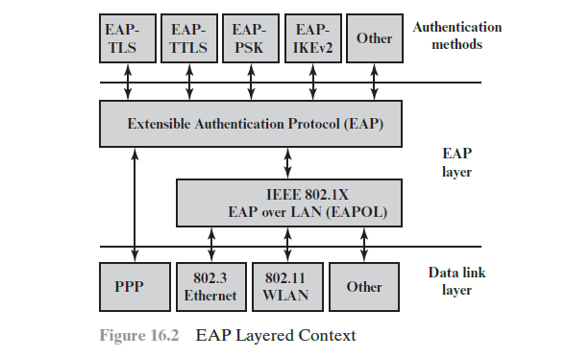

EAP Exchanges
Whatever method is used for authentication, the authentication information and authentication protocol information are carried in EAP messages.
The following components are involved:
- EAP peer: Client computer that is attempting to access a network.
- EAP authenticator: An access point or NAS that requires EAP authentication prior to granting access to a network.
- Authentication server: The authentication server functions as a backend server that can authenticate peers as a service to a number of EAP authenticators. The EAP authenticator then makes the decision of whether to grant access.
This is referred to as the EAP pass-through mode.

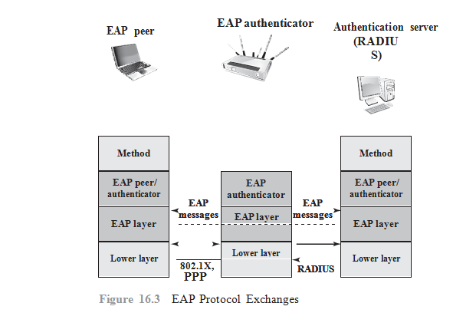
EAP messages may include the following fields:
- Code: Identifies the Type of EAP message. The codes are Request (1), Response (2), Success (3), and Failure (4).
- Identifier: Used to match Responses with Requests.
- Length: Indicates the length, in octets, of the EAP message, including the Code, Identifier, Length, and Data fields.
- Data: Contains information related to authentication.

IEEE 802.1X PORT-BASED NETWORK ACCESS CONTROL
IEEE 802.1X Port-Based Network Access Control was designed to provide access control functions for LANs.

Terminology Related to IEEE 802.1X
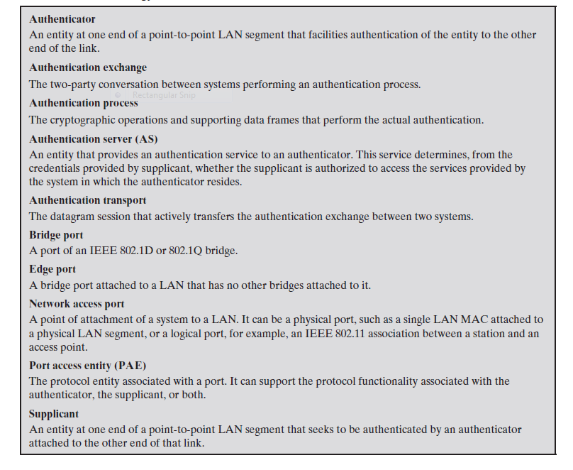
- The terms supplicant, network access point, and authentication server correspond to the EAP terms peer, authenticator, and authentication server, respectively.
- Until the AS authenticates a supplicant (using an authentication protocol), the authenticator only passes control and authentication messages between the supplicant and the AS
- Once a supplicant is authenticated and keys are provided, the authenticator can forward data from the supplicant.

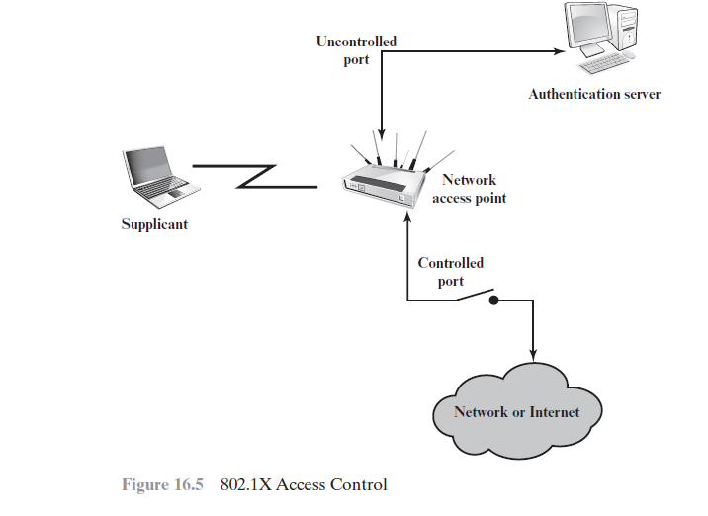
- 802.1X uses the concepts of controlled and uncontrolled ports.
- Ports are logical entities defined within the authenticator and refer to physical network connections.
- Each logical port is mapped to one of these two types of physical ports.
- An uncontrolled port allows the exchange of protocol data units (PDUs) between the supplicant and the AS, regardless of the authentication state of the supplicant.
- A controlled port allows the exchange of PDUs between a supplicant and other systems on the network only if the current state of the supplicant authorizes such an exchange.
- The essential element defined in 802.1X is a protocol known as EAPOL (EAP over LAN). EAPOL operates at the network layers and makes use of an IEEE 802 LAN, such as Ethernet or Wi-Fi, at the link level.
- EAPOL enables a supplicant to communicate with an authenticator and supports the exchange of EAP packets for authentication.

IP SECURITY

Applications of IPSec
IPSec provides the capability to secure communications across a LAN, across private and public WANs, and across the Internet. Examples of its use include the following:
- Secure branch office connectivity over the Internet
- Secure remote access over the Internet
- Establishing extranet and intranet connectivity with partners
- Enhancing electronic commerce security

Benefits of IPSec:
- When IPSec is implemented in a firewall or router, it provides strong security
- IPSec in a firewall is resistant to bypass if all traffic from the outside must use IP, and the firewall is the only means of entrance from the Internet into the organization.
- IPSec is below the transport layer (TCP, UDP) and so is transparent to applications.
- IPSec can provide security for individual users if needed.

IP SECURITY ARCHITECTURE

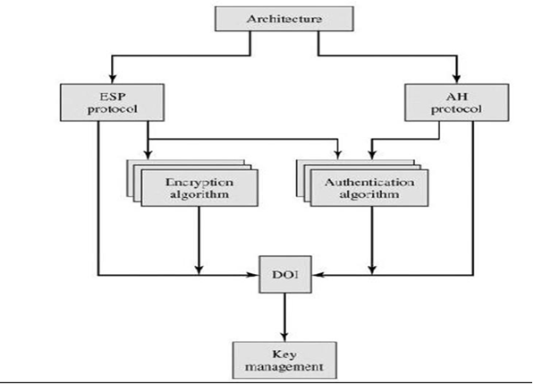

1. Architecture: Covers the general concepts, security requirements, definitions, and mechanisms defining IPSec technology.

2.Encapsulating Security Payload (ESP):
ESP(Encapsulation Security Payload) provides a confidentiality service.
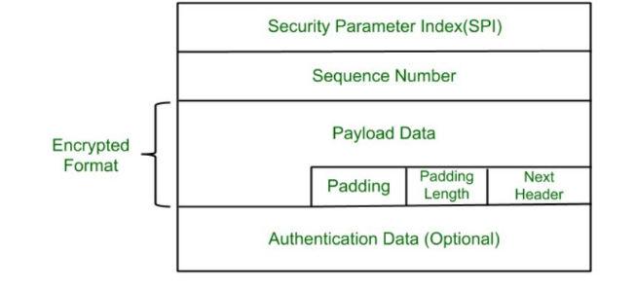
- Security Parameter Index(SPI): This parameter is used by Security Association. It is used to give a unique number to the connection built between the Client and Server.
- Sequence Number: Unique Sequence numbers are allotted to every packet so that on the receiver side packets can be arranged properly.
- Payload Data: Payload data means the actual data or the actual message. The Payload data is in an encrypted format to achieve confidentiality.
- Padding: Extra bits of space are added to the original message in order to ensure confidentiality. Padding length is the size of the added bits of space in the original message.
- Next Header: Next header means the next payload or next actual data.
- Authentication Data This field is optional in ESP protocol packet format.

3.Authentication Header (AH):
The Authentication Header provides support for data integrity and authentication of IP packets.
The Authentication Header consists of the following fields:
- Next Header (8 bits): Identifies the type of header immediately following this header.
- Payload Length (8 bits): Length of Authentication Header in 32-bit words, minus 2.
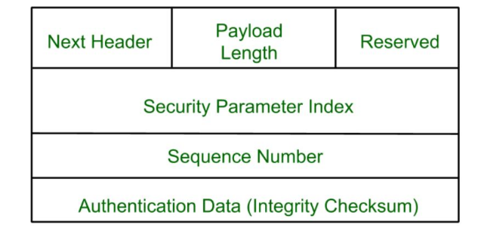
- Reserved (16 bits): For future use.
- Security Parameters Index (32 bits): Identifies a security association.
- Sequence Number (32 bits): A monotonically increasing counter value.
- Authentication Data (variable): A variable-length field (must be an integral number of 32-bit words) that contains the Integrity Check Value (ICV), or MAC

4.Encryption Algorithm:

The encryption algorithm is the document that describes various encryption algorithms used for Encapsulation Security Payload.

5.Authentication Algorithm:
The authentication Algorithm contains the set of documents that describe the authentication algorithm used for AH and for the authentication option of ESP.

6. Key Management:
Key Management contains the document that describes how the keys are exchanged between sender and receiver.

7. Domain of Interpretation (DOI):
DOI is the identifier that supports both AH and ESP protocols.

Modes of Transfer
Both AH and ESP support two modes of use:
- transport and
- tunnel mode.

Transport Mode:
Transport mode provides protection primarily for upper-layer protocols.

Tunnel Mode:
Tunnel mode provides protection to the entire IP packet.

IP Security Policy
IPsec policy is determined primarily by the interaction of two databases, the security association database (SAD) and the security policy database (SPD).

Security Associations
An association is a one-way logical connection between a sender and a receiver that affords security services to the traffic carried on it.
A security association is uniquely identified by three parameters.
- Security Parameters Index (SPI): A 32-bit unsigned integer assigned to this SA and having local significance only. The SPI is carried in AH and ESP headers to enable the receiving system to select the SA under which a received packet will be processed.
- IP Destination Address: This is the address of the destination endpoint of the SA, which may be an end-user system or a network system such as a firewall or router.
- Security Protocol Identifier: This field from the outer IP header indicates whether the association is an AH or ESP security association.

INTERNET KEY EXCHANGE
- Internet Key Exchange (also known as IKE, IKEv1 or IKEv2) is a protocol that is used to generate a security association within the Internet Protocol Security protocol suite.
- It is often used as a method of exchanging encryption keys and/or authentication keys through an unsecured medium like the Internet.
- The Internet Key Exchange protocol has its roots in the Oakley Protocol, SKEME and ISAKMP, as a result it is often referred to as a hybrid protocol.
- Internet Key Exchange(IKE) is a key management protocol used to secure communication and key exchange between two devices over any network. Key exchange is done in two ways:

Manual Key Exchange
- In Manual Key Exchange, the system administrator manually configures each system with their keys.
Automated Key Exchange
- The keys will be created or generated based on the demand or requirement.

- Oakley Key Determination Protocol: Oakley key determination protocol is based on the Diffie-Hellman key exchange protocol with some added security. It is a generic protocol.
- ISAKMP(Internet Security Association and Key Management Protocol): It provides a framework for key exchange and specific support i.e the protocol can be either Authentication Header or Encapsulation Security Protocol.
- SKEME Protocol: It is a key exchange technique that provides anonymity, non-repudiation, and refreshment.

Key Determination Protocol
IKE key determination is a refinement of the Diffie-Hellman key exchange algorithm.
Diffie-Hellman involves the following interaction between users A and B.
There is prior agreement on two global parameters: q, a large prime number; and a, a primitive root of q.
A selects a random integer XA as its private key and transmits to B its public key VA = a^{XA} mod q. Similarly, B selects a random integer XB as its private key and transmits to A it’s public key
VB = a^{XB} mod q.
Each side can now compute the secret session key:
K = (VB)^{XA} mod q
K = (VA)^{XB} mod q

The Diffie-Hellman algorithm has two attractive features:
• Secret keys are created only when needed.
• The exchange requires no pre-existing infrastructure other than an agreement on the global parameters.

There are a number of weaknesses to Diffie-Hellman,
• It does not provide any information about the identities of the parties.
• It is subject to a man-in-the-middle attack, in which a third party C
impersonates B while communicating with A and impersonates A while communicating with B.

Features of IKE Key Determination
The IKE key determination algorithm is characterized by five important features:
1. It employs a mechanism known as cookies to prevent clogging attacks.
2. It enables the two parties to negotiate a group; this, in essence, specifies the global parameters of the Diffie-Hellman key exchange.
3. It uses nonces to ensure against replay attacks.
4. It enables the exchange of Diffie-Hellman public key values.
5. It authenticates the Diffie-Hellman exchange to prevent man-in-the-middle attacks.

Three different authentication methods can be used with IKE key determination:
• Digital signatures
• Public-key encryption
• Symmetric-key encryption

IKE Header Format
An IKE message consists of an IKE header followed by one or more payloads.
All of this is carried in a transport protocol.
The specification dictates that implementations must support the use of UDP for the transport protocol.
The Figure shows the header format for an IKE message.
It consists of the following fields.
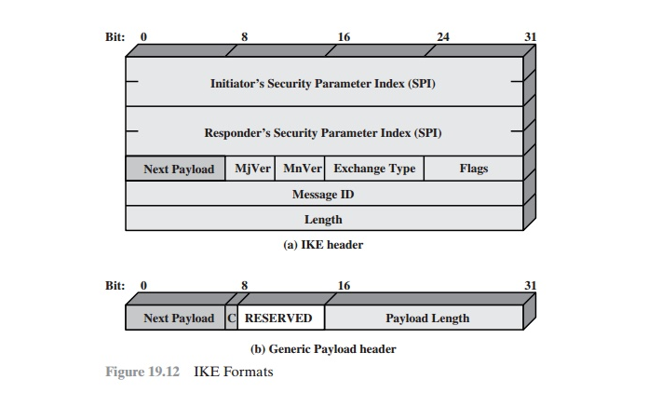
• Initiator SPI (64 bits): A value chosen by the initiator to identify a unique IKE security association (SA).
• Responder SPI (64 bits): A value chosen by the responder to identify a unique IKE SA.
• Next Payload (8 bits): Indicates the type of the first payload in the message. • Major Version (4 bits): Indicates major version of IKE in use.
• Minor Version (4 bits): Indicates minor version in use.
- Exchange Type (8 bits): Indicates the type of exchange.
• Flags (8 bits): Indicates specific options set for this IKE exchange.
• Message ID (32 bits): Used to control retransmission of lost packets and matching of requests and responses.
• Length (32 bits): Length of total message (header plus all payloads) in octets.

TRANSPORT-LEVEL SECURITY
WEB SECURITY CONSIDERATIONS
The World Wide Web is fundamentally a client/server application running over the Internet and TCP/IP intranets.

Web Security Threats
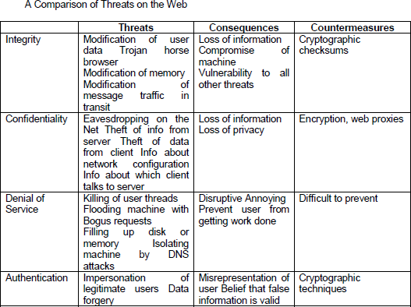
Two types of attacks are:
- Passive attacks include eavesdropping on network traffic between browser and server and gaining access to information on a Web site that is supposed to be restricted.
- Active attacks include impersonating another user, altering messages in transit between client and server, and altering information on a Web site.

SECURE SOCKET LAYER SECURITY

SSL Architecture
- SSL is designed to make use of TCP to provide a reliable end-to-end secure service.
- The SSL Record Protocol provides basic security services to various higher-layer protocols.
- Hypertext Transfer Protocol (HTTP), which provides the transfer service for Web client/server interaction, can operate on top of SSL.
- Three higher-layer protocols are defined as part of SSL: the Handshake Protocol, The Change Cipher Spec Protocol, and the Alert Protocol
- Two important SSL concepts are the SSL session and the SSL connection, which are defined in the specification as follows:

Connection:
- A connection is a transport (in the OSI layering model definition) that provides a suitable type of service. For SSL, such connections are peer-to-peer relationships.
- The connections are transient.
- Every connection is associated with one session.
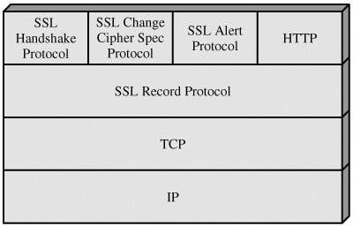

SSL Protocol Stack

Session:
- An SSL session is an association between a client and a server.
- Sessions are created by the Handshake Protocol.
- Sessions define a set of cryptographic security parameters, which can be shared among multiple connections.
- Sessions are used to avoid the expensive negotiation of new security parameters for each connection

A session state is defined by the following parameters
- Session identifier
- Peer certificate
- Compression method
- Cipher spec
- Master secret
- Is resumable

A connection state is defined by the following parameters:
- Server and client random
- Server write MAC secret
- Client write MAC secret
- Server write key
- Client write key.
- Initialization vectors
- Sequence numbers

SSL Record Protocol
The SSL Record Protocol provides two services for SSL connections:
Confidentiality: The Handshake Protocol defines a shared secret key that is used for conventional encryption of SSL payloads.
Message Integrity: The Handshake Protocol also defines a shared secret key that is used to form a message authentication code (MAC).

The Record Protocol takes an application message to be transmitted, fragments the data into manageable blocks, optionally compresses the data, applies a MAC, encrypts, adds a header, and transmits the resulting unit in a TCP segment.
Received data are decrypted, verified, decompressed, and reassembled and then delivered to higher-level users.
The first step is fragmentation. Each upper-layer message is fragmented into blocks of 214 bytes (16384 bytes) or less.
Next, compression is optionally applied.
The next step in processing is to compute a message authentication code over the compressed data.
The final step of SSL Record Protocol processing is to prepend a header, consisting of the following fields:
- Content Type (8 bits): The higher layer protocol used to process the enclosed fragment.
- Major Version (8 bits): Indicates major version of SSL in use. For SSLv3, the value is 3.
- Minor Version (8 bits): Indicates minor version in use. For SSLv3, the value is 0.
- Compressed Length (16 bits): The length in bytes of the plaintext fragment (or compressed fragment if compression is used).
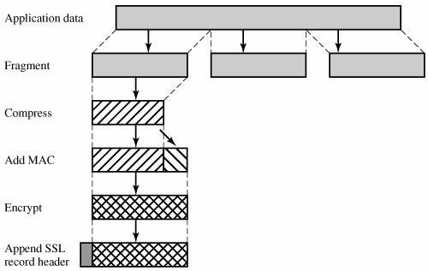

SSL Record Protocol Operation
Change Cipher Spec Protocol
This protocol consists of a single message which consists of a single byte with the value

Alert Protocol
The Alert Protocol is used to convey SSL-related alerts to the peer entity.

Handshake Protocol
This protocol allows the server and client to authenticate each other and to negotiate an encryption and MAC algorithm and cryptographic keys to be used to protect data sent in an SSL record. The Handshake Protocol is used before any application data is transmitted. The Handshake Protocol consists of a series of messages exchanged by client and server.

TRANSPORT LAYER SECURITY
TLS is an Internet standard that evolved from a commercial protocol known as Secure Sockets Layer (SSL).

TLS Architecture

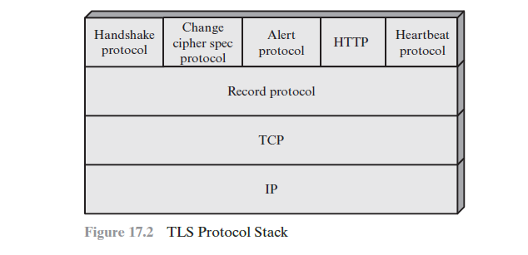
The TLS Record Protocol provides basic security services to various higher- layer protocols. In particular, the Hypertext Transfer Protocol (HTTP), which provides the transfer service for Web client/server interaction, can operate on top of TLS. Three higher-layer protocols are defined as part of TLS: the Handshake Protocol; the Change Cipher Spec Protocol; and the Alert Protocol.

Two important TLS concepts are the TLS session and the TLS connection, which are defined in the specification as follows:
- Connection:
- A connection is a transport that provides a suitable type of service.
- The connections are transient.
- Every connection is associated with one session.
- Session:
- A TLS session is an association between a client and a server.
- Sessions are created by the Handshake Protocol.
- Sessions define a set of cryptographic security parameters, which can be shared among multiple connections.
A session state is defined by the following parameters:
- Session identifier: An arbitrary byte sequence chosen by the server to identify an active or resumable session state.
- Peer certificate: An X509.v3 certificate of the peer. This element of the state may be null.
- Compression method: The algorithm used to compress data prior to encryption.
- Cipher spec: Specifies the bulk data encryption algorithm (such as null, AES, etc.) and a hash algorithm (such as MD5 or SHA-1) used for MAC calculation. It also defines cryptographic attributes such as the hash_size.
- Master secret: 48-byte secret shared between the client and server.
- Is resumable: A flag indicating whether the session can be used to initiate new connections.

A connection state is defined by the following parameters:
- Server and client random: Byte sequences that are chosen by the server and client for each connection.
- Server write MAC secret: The secret key used in MAC operations on data sent by the server.
- Client write MAC secret: The symmetric key used in MAC operations on data sent by the client.
- Server write key: The symmetric encryption key for data encrypted by the server and decrypted by the client.
- Client write key: The symmetric encryption key for data encrypted by the client and decrypted by the server.
- Initialization vectors: When a block cipher in CBC mode is used, an initialization vector (IV) is maintained for each key.
- Sequence numbers: Each party maintains separate sequence numbers for transmitted and received messages for each connection.

TLS Record Protocol
The TLS Record Protocol provides two services for TLS connections:
- Confidentiality: The Handshake Protocol defines a shared secret key that is used for conventional encryption of TLS payloads.
- Message Integrity: The Handshake Protocol also defines a shared secret key that is used to form a message authentication code (MAC).
- 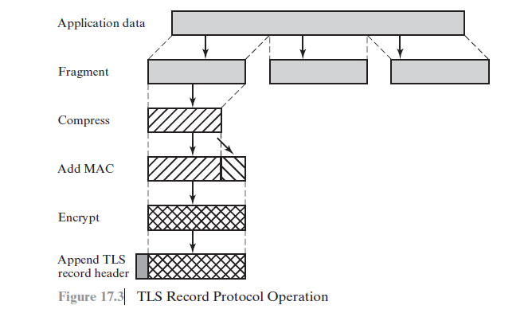

Change Cipher Spec Protocol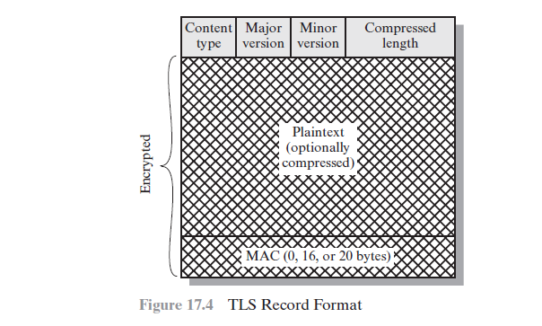

The Change Cipher Spec Protocol is one of the four TLS-specific protocols that use the TLS Record Protocol, and it is the simplest.
This protocol consists of a single message which consists of a single byte with the value 1.
Alert Protocol
The Alert Protocol is used to convey TLS-related alerts to the peer entity.

Handshake Protocol
The most complex part of TLS is the Handshake Protocol. This protocol allows the server and client to authenticate each other and to negotiate an encryption and MAC algorithm and cryptographic keys to be used to protect data sent in a TLS record.
The Handshake Protocol consists of a series of messages exchanged by client and server. Each message has three fields:
Type (1 byte): Indicates one of 10 messages. Table 17.2 lists the defined mes- sage types.
Length (3 bytes): The length of the message in bytes.
Content ( # 0 bytes): The parameters associated with this message.

Handshake protocol action
PHASE 1. ESTABLISH SECURITY CAPABILITIES
Phase 1 initiates a logical connection and establishes the security capabilities that will be associated with it.
The exchange is initiated by the client, which sends a client_hello message with the following parameters:
Version: The highest TLS version understood by the client.
Random: A client-generated random structure consisting of a 32-bit time- stamp and 28 bytes generated by a secure random number generator.
Session ID: A variable-length session identifier. A nonzero value indicates that the client wishes to update the parameters of an existing connection or to create a new connection on this session. A zero value indicates that the client wishes to establish a new connection on a new session.
CipherSuite: This is a list that contains the combinations of cryptographic algorithms supported by the client, in decreasing order of preference. Compression Method: This is a list of the compression methods the client supports.

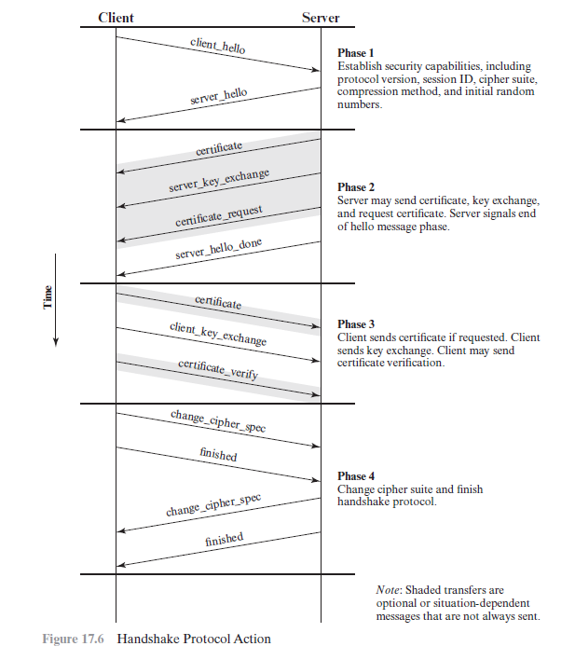

After sending the client_hello message, the client waits for the server_ hello message, which contains the same parameters as the client_hello

PHASE 2. SERVER AUTHENTICATION AND KEY EXCHANGE The server begins this phase by sending its certificate if it needs to be authenticated; the message contains one or a chain of X.509 certificates. The certificate message is required for any agreed-on key exchange method except anonymous Diffie–Hellman.

PHASE 3. CLIENT AUTHENTICATION AND KEY EXCHANGE
Upon receipt of the server_done message, the client should verify that the server provided a valid certificate and check that the server_hello parameters are acceptable. If all is satisfactory, the client sends one or more messages back to the server. If the server has requested a certificate, the client begins this phase by sending a certificate message. If no suitable certificate is available, the client sends a no_certificate alert instead.
Next is the client_key_exchange message, which must be sent in this phase.
PHASE 4. FINISH
Phase 4 completes the setting up of a secure connection. The client sends a change_cipher_spec message and copies the pending CipherSpec into the current CipherSpec.

HTTPS standard
HTTPS (HTTP over SSL) refers to the combination of HTTP and SSL to imple- ment secure communication between a Web browser and a Web server.

Connection Initiation
For HTTPS, the agent acting as the HTTP client also acts as the TLS client. The client initiates a connection to the server on the appropriate port and then sends the TLS ClientHello to begin the TLS handshake.
When the TLS handshake has finished, the client may then initiate the first HTTP request. All HTTP data is to be sent as TLS application data.
There are three levels of awareness of a connection in HTTPS.
At the HTTP level, an HTTP client requests a connection to an HTTP server by sending a connection request to the next lowest layer.
Typically, the next lowest layer is TCP, but it also may be TLS/SSL.
At the level of TLS, a session is established between a TLS client and a TLS server. This session can support one or more connections at any time.
As we have seen, a TLS request to establish a connection begins with the establishment of a TCP connection between the TCP entity on the client side and the TCP entity on the server side.

Connection Closure
An HTTP client or server can indicate the closing of a connection by including the following line in an HTTP record: Connection: close.
This indicates that the connection will be closed after this record is delivered.

SECURE SHELL (SSH)
Secure Shell (SSH) is a protocol for secure network communications designed to be relatively simple and inexpensive to implement.
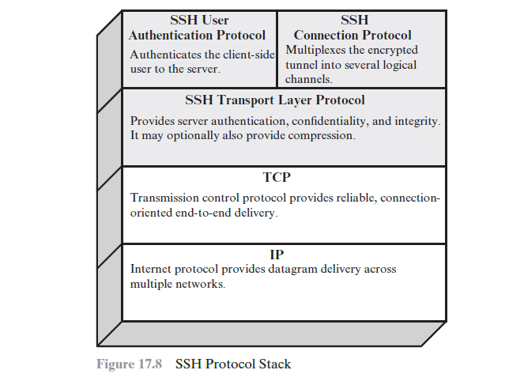
SSH is organized as three protocols that typically run on top of TCP.
Transport Layer Protocol: Provides server authentication, data confidentiality, and data integrity with forward secrecy (i.e., if a key is compromised during one session, the knowledge does not affect the security of earlier sessions). The transport layer may optionally provide compression.
User Authentication Protocol: Authenticates the user to the server.
Connection Protocol: Multiplexes multiple logical communications channels over a single, underlying SSH connection.

Packet Exchange
First, the client establishes a TCP connection to the server. This is done via the TCP protocol and is not part of the Transport Layer Protocol.
Once the connection is established, the client and server exchange data, referred to as packets, in the data field of a TCP segment.
Each packet is in the following format.
Packet length: Length of the packet in bytes, not including the packet length and MAC fields.
Padding length: Length of the random padding field.
Payload: Useful contents of the packet.
Random padding: It contains random bytes of padding so that the total length of the packet is a multiple of the cipher block size, or 8 bytes for a stream cipher.
Message authentication code (MAC): The MAC value is computed over the entire packet plus a sequence number, excluding the MAC field. The sequence number is an implicit 32-bit packet sequence that is initialized to zero for the first packet and incremented for every packet. The sequence number is not included in the packet sent over the TCP connection.
The Figure illustrates the basic concept behind port forwarding. We have a client application that is identified by port number x and a server application identified by port number y. At some point, the client application invokes the local TCP entity and requests a connection to the remote server on port y. The local TCP entity negotiates a TCP connection with the remote TCP entity, such that the connection links local port x to remote port y.

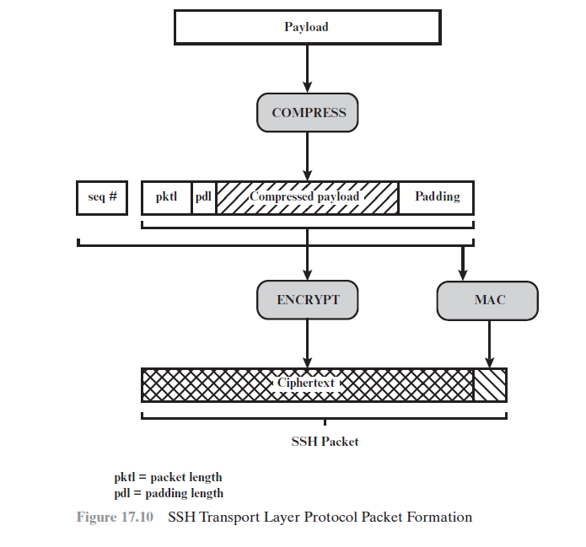
To secure this connection, SSH is configured so that the SSH Transport Layer Protocol establishes a TCP connection between the SSH client and server entities, with TCP port numbers a and b, respectively.
A secure SSH tunnel is established over this TCP connection. Traffic from the client at port x is redirected to the local SSH entity and travels through the tunnel where the remote SSH entity delivers the data to the server application on port y. Traffic in the other direction is similarly redirected.

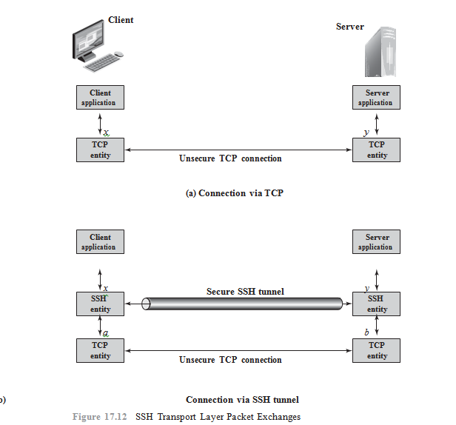
SSH supports two types of port forwarding: local forwarding and remote for- warding. Local forwarding allows the client to set up a “hijacker” process. This will intercept selected application-level traffic and redirect it from an unsecured TCP connection to a secure SSH tunnel.
With remote forwarding, the user’s SSH client acts on the server’s behalf. The client receives traffic with a given destination port number, places the traffic on the correct port and sends it to the destination the user chooses.

